**Name:** Tanmay Vig

**Roll No:** 19BCS061

**Class:** 3rd year B. Tech CSE

**Experiment 2**: Design and implement Embedded System for blinking single LED with some delay in between, using 8051 Microcontroller and Keil.

**Stuff Required:** KEIL µVISION IDE, WINDOWS OS.

**Program:**

File name: prog.c

#include<p89v51rd2.h>

void delay(unsigned int d){

unsigned int i,j;

for(i=0;i<=1000;i++){

for(j=0;j<=d;j++);

}

}

void main(void){

while(1){

RxD=0;

delay(20);

RxD=1;

delay(20);

}

}

File name: P2.hex

**Instructions:**

1. Launch KEIL µVISION IDE.
2. Start new Project (here P2).
3. After writing the code. Debug the code by going to Debug dropdown from options menu above and choose Start/Stop Debug Session.
4. Go to Peripherals dropdown choose I/O-Ports then choose port 3.
5. Press F5 or again navigate to Debug dropdown and choose Run.
6. 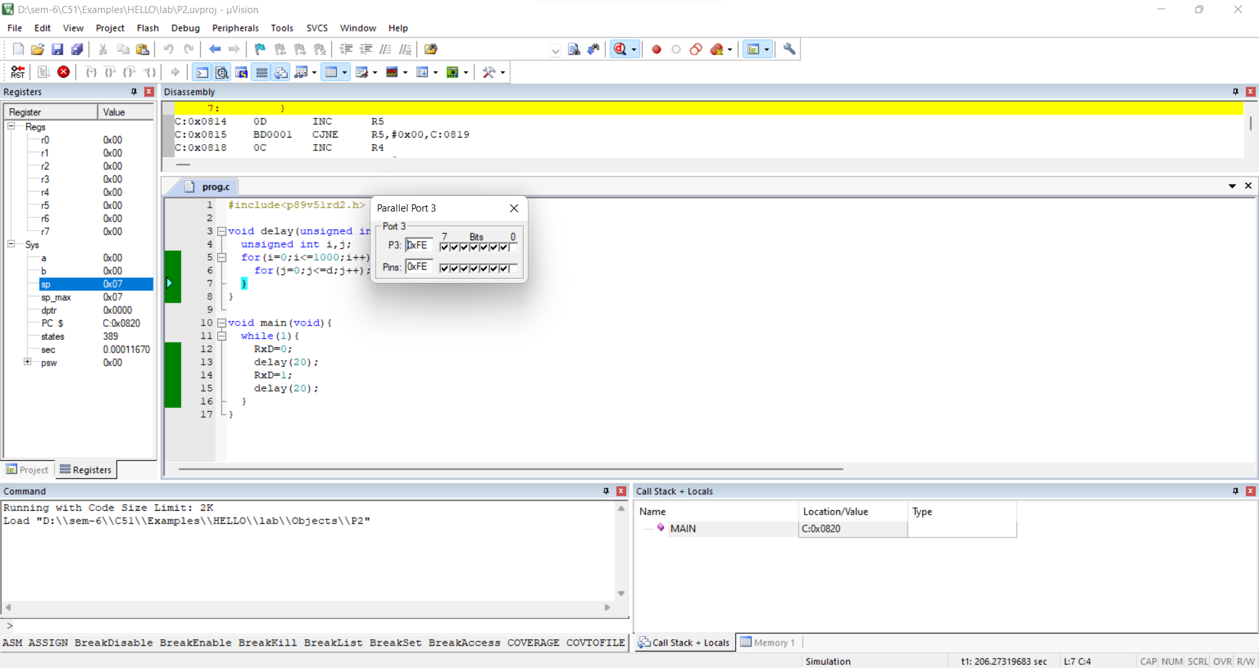The 0th LED on Port 3 blinks.

0th LED

1. Navigate to Debug again and select stop to Stop Debug.

**Result:**

LED Blinking implemented.